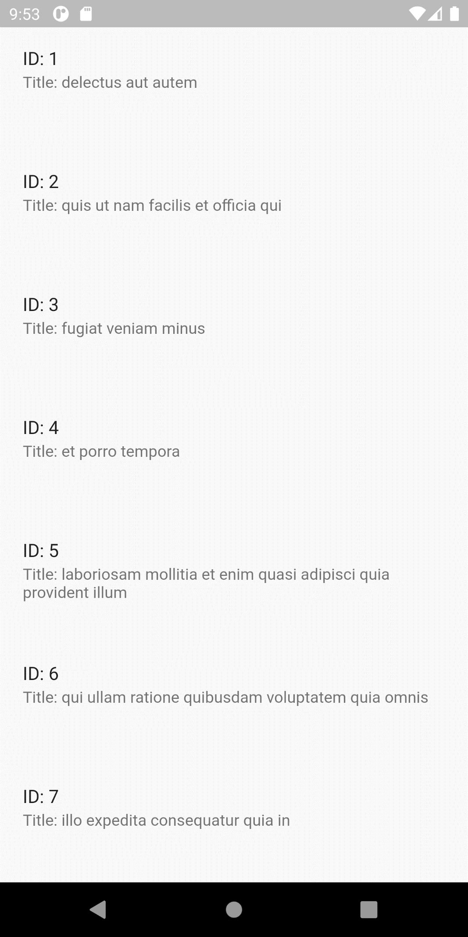

# Code

## Main.dart

import 'package:flutter/material.dart';  
import 'package:madlab10/api_service.dart';  
  
void main() {  
 runApp(MyApp());  
}  
  
class MyApp extends StatelessWidget {  
 @override  
 Widget build(BuildContext context) {  
 return MaterialApp(  
 debugShowCheckedModeBanner: false,  
 home: HomePage()  
 );  
 }  
}  
  
class HomePage extends StatefulWidget {  
 @override  
 _HomePageState createState() => _HomePageState();  
}  
  
class _HomePageState extends State<HomePage> {  
 @override  
 Widget build(BuildContext context) {  
 return Scaffold(  
 body: SafeArea(  
 child: FutureBuilder(  
 future: fetchData(),  
 builder: (context, snapshot){  
 if (snapshot.hasData){  
 return ListView.separated(  
 separatorBuilder: (context, index) => SizedBox(height: 10,),  
 itemBuilder: (context, index){  
 return ListTile(  
 contentPadding: EdgeInsets.symmetric(horizontal: 20, vertical: 5),  
 dense: false,  
 isThreeLine: true,  
 title: Text("ID: " + snapshot.data[index].id.toString()),  
 subtitle: Text("Title: " + snapshot.data[index].title),  
 );  
 },  
 itemCount: snapshot.data.length,  
 );  
 }  
 else{  
 if (snapshot.hasError){  
 return AlertDialog(  
 title: Text("Error"),  
 content: Text(snapshot.error.toString()),  
 actions: [  
 FlatButton(  
 child: Text("Retry"),  
 onPressed: (){  
 Navigator.*of*(context).pop();  
 Navigator.*of*(context).pushReplacement(MaterialPageRoute(builder: (context) => HomePage()));  
 },  
 )  
 ],  
 );  
 }  
 }  
 return CircularProgressIndicator();  
 },  
 ),  
 ),  
 );  
 }  
}

## apiservice.dart

import 'package:http/http.dart' as http;  
import 'package:madlab10/model/api_model.dart';  
import 'dart:convert';  
  
Future <List<apiModel>> fetchData() async {  
 final response =  
 await http.get(Uri.*parse*('https://jsonplaceholder.typicode.com/todos'));  
 if (response.statusCode == 200) {  
 List<apiModel> list = [];  
 json.decode(response.body).forEach((item){list.add(apiModel.fromJson(item));});  
 return list;  
 } else {  
 throw Error();  
 }  
}

## api_model.dart

class apiModel{  
 int id;  
 String title;  
 bool completed;  
  
 apiModel.fromJson(Map<String,dynamic> map){  
 id = map['id'];  
 title = map["title"];  
 completed = map["completed"];  
 }  
}